…Bond portfolio strategies are too many to enumerate. But there are benchmark bond strategies which are frequently introduced to textbook. Among them are bullet, barbell, ladder and buy-and-hold portfolios. For these bond portfolios, we are going to calculate monthly and cumulative returns.

We assume the case of zero coupon bond portfolio for empirical exercises. Without target duration constraints, differences between zero coupon bond and coupon bearing bond are not large. It is well known that the coupon bond is the portfolio of zero coupon bonds.

1. Bullet : maintain one bond with its maturity fixed
2. Barbell : maintain two bonds with each maturities fixed and equal weights(1/2)
3. Ladder : maintain all relevant bonds with each maturity fixed and equal weights(1/n)
4. Buy and Hold : buy and hold one bond until its maturity and maintain this trade periodically

# Return Calculation

At first, we need to calculate monthly returns of each bond. After getting these monthly returns, we can construct monthly returns of 4 portfolios.

The price of a pure discount (zero coupon) bond with maturity \(\tau\) at time t is the discounted value of 1 receivable \(\tau\) periods later. \[\begin{align} P_t^{[\tau]} =exp(-\tau \times s_t^{[\tau]}) \end{align}\] Here, \(s_t^{[\tau]}\) is the spot rate.

Using the log-return expression, the monthly holding period return is as follows.

\[\begin{align} r_t^{[\tau]}& = \log {P_t^{\left[\tau-\frac{1}{12}\right]}} – \log {P_{t-1}^{\left[\tau

\right]}} \\ &= \left(\tau-\frac{1}{12}\right) \times s_t^{\left[\tau-\frac{1}{12}\right]} – \tau \times s_{t-1}^{\left[\tau\right]} \end{align}\]

However, yield curve is reported for some major relevant maturities such as 1-year or 3-year, and so on. In most cases, \(s_t^{\left[\tau-\frac{1}{12}\right]}\) are not observed. Therefore, we need to interpolate these unobserved spot rates using observed spot rates. If \(s_t^{\left[\tau-

\frac{1}{12}\right]}\) are interpolated using spline or linear interpolation or Nelson-Siegel model, we can apply the above log-return expression to these interpolated spot rates. For our study, we use the spline interpolation using **splinefun** R function.

Now it is ready to use the time \(t-1\) spot rates with maturities \(1\), \(3\), \(5\), \(7\), and \(10\) and the time \(t\) spot rates with maturities \(1-\frac{1}{12}\), \(3-\frac{1}{12}\), \(5-\frac{1}{12}\),

\(7-\frac{1}{12}\), and \(10-\frac{1}{12}\) to calculate monthly returns for each selected maturity.

# Monthly Returns of Portfolio

Given time series of monthly spot rate for each maturity, monthly returns of each bullet portfolio is the same as the previous monthly returns of each column respectively. It is only to read each column which corresponds each maturity respectively.

It is also easy to calculate monthly returns for barbell, and ladder. For barbell, 1- and 10-year returns are averaged. For ladder, returns of all 5 maturities are averaged. But for Buy-and-Hold, some caution is needed.

Buy-and-Hold (BH) strategy 1) buy a bond with issuance maturity and 2) hold it until maturity. Therefore, as soon as redemption is made, new BH strategy starts with a full issuance maturity. This means that remaining maturity shows periodic behavior. For example, time variation of remaining maturity of 3-year BH portfolio is as follows.

\[\begin{align} 2 &\rightarrow 1.92 \rightarrow 1.83 \rightarrow… \\ &\rightarrow 0.17 \rightarrow

0.08 \rightarrow 2 \rightarrow 1.92 \rightarrow … \end{align}\]

The following figure shows the pattern of remaining maturity of BH portfolio with selected maturities.

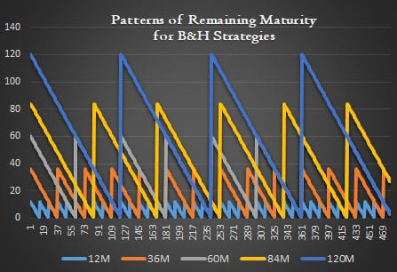

Hence, monthly return series for BH portfolios for each maturity are defined in in full interpolation monthly return grid. As time passes, position of current spot rates are moved to the left by \(\frac{1}{12}\) in full interpolated spot rate grid until its maturity approaches zero. Of course, after redemption take places, position of current spot rate goes back to the original position which corresponds to the issuance maturity.

# R code for Bond Portfolio

The following R code demonstrates the calculation of monthly and cumulative returns of 4 benchmark bond portfolio using Diebold, Rudebusch, and Aruoba (2006) data,

1 #===========================================================

2 ==============#

4

5

6

7 #————————————————————————-#

8 # Benchmark Bond Portfolio Return Calculation cs

9 #===========================================================

10 ==============#

11

1. library(readxl)
2. library(xlsx)
3. library(RColorBrewer) 15
4. graphics.off() # clear all graphs
5. rm(list = ls()) # remove all files from your workspace 18

19 setwd(“D:/SHLEE/a_blog_ki_and_Lee/bond_portfolio”) 20

21 #——————————————————

22 # 0) Read DRA (2006) spot yield curve data 23 #—————————————————— 24

25 fname <– “dra_spot_cc_data.xlsx” 26

1. # maturity, date, spot rate
2. vmatm <– read_excel(fname, “spotcc”,“B1:R1”, col_names = FALSE)
3. df.ym <– read_excel(fname, “spotcc”,“A2:A480”, col_names = FALSE)
4. df.spot <– read_excel(fname, “spotcc”,“B2:R480”, col_names = FALSE) 31
5. # maturity as decimal, spot as y
6. vmatm <– as.numeric(vmatm); vmaty <– vmatm/12
7. y <– as.matrix(df.spot/100);
8. colnames(y) <– vmatm 36
9. # counting
10. nmat <– length(vmaty);
11. ny <– nrow(y); nr <– ny – 1; # number of yields and returns 40

41 #——————————————————

42 # 1) Interpolate monthly spot rates using cubic spline 43 #——————————————————

44

45 # .ip : interpolated 46

1. # use 0 for 1-month return temporarily
2. matm.ip <– (0:max(vmatm))
3. max.matm.ip <– max(matm.ip) 50
4. # use apply() for row-wise interpolation
5. # output => collection of column vector => so transpose
6. y.ip <– t(apply(y, 1,
7. function (x) {
8. # make interpolation function
9. fs<–splinefun(vmatm,x);
10. # apply fs function to each row
11. fs(matm.ip)

59 }

60 ))

61

62 #——————————————————

63 # 2) Calculate 1-month returns

64 #——————————————————

65

1. # interpolated spot rate
2. r.ip <– matrix(0, ny–1, length(matm.ip)–1) 68
3. # calculate monthly returns
4. for (t in 2:ny) { 71
5. # spot rates and maturities at t and (t-1)
6. spot.t <– y.ip[t,1:max.matm.ip]

74 spot.t_1 <– y.ip[t–1,2:(max.matm.ip+1)]

1. mat.t <– matm.ip[1:max.matm.ip]/12
2. mat.t_1 <– matm.ip[2:(max.matm.ip+1)]/12 77
3. # log-return expression
4. r.ip[t–1,] = log(exp(–spot.t*mat.t)/exp(–spot.t_1*mat.t_1)) 80 }

81

1. # draw a graph for monthly returns
2. x11(width=6, height=4);

84 par(mar = c(5, 4, 4, 6) + 0.1)

85 matplot(r.ip[,c(120, 60, 36, 12, 3)], type = “l”, lty = 1,

1. col = c(brewer.pal(4, “Paired”),“black”),
2. ylab = “return”, xlab = “date”, lwd = 2,
3. main = “Monthly Zero Coupon Bond Returns”)
4. legend(“right”, inset = c(–0.3,0),

90 legend = paste(c(120, 60, 36, 12, 3),“M”), xpd = TRUE,

1. horiz = FALSE, col = c(brewer.pal(4, “Paired”),“black”),
2. lty = 1, bty = “n”, lwd = 2) 93

94 #——————————————————

1. # 3) Construct benchmark bond portfolios
2. # – barbell, bullet, ladder, Buy-and-Hold 97 #—————————————————— 98

99 # selected maturity

100 maty_bm <– c(1,3,5,7,10)

1. matm_bm <– maty_bm*12
2. nc <– length(maty_bm) # number of selected maturities 103

104 # 1. Barbell (1, 10 year) 105 maty1 <– c(1,10)

1. col1.ret <– rowMeans(r.ip[1:nr, maty1*12])
2. col1.dur <– matrix(1/2, nr,2)%*%maty1 108
3. # 2. Bullet
4. col2.ret <– r.ip[1:nr, matm_bm]
5. colnames(col2.ret) <– paste0(“Bullet(“, maty_bm, “)”)
6. col2.dur <– matrix(1,nr,nc)%*%diag(maty_bm);
7. colnames(col2.dur) <– colnames(col2.ret) 114
8. # 3. Ladder (equal weights for all maturities)
9. col3.ret <– rowMeans(r.ip[1:nr, matm_bm])
10. col3.dur <– matrix(1/nc, nr, nc)%*%maty_bm 118
11. # 4. Buy-and-Hold
12. bah.ret <– bah.maty <– bah.matm <– matrix(0,nr, nc)
13. for (t in 1:nr) { for(j in 1:nc) { 122
14. # As t move forward, remaining maturity decreases.
15. # When remaining maturity is zero,
16. # a new bond is purchased
17. # the remaining maturity is set to the issuance maturity.
18. matm <– matm_bm[j]–(t–1)%%matm_bm[j] 128

129

130

131

132

133

134

135

136

137

138

139

140

141

142

143

144

145

146

147

148

149

150

151

152

153

154

155

156

157

158

159

160

161

162

163

164

165

166

167

168

bah.matm[t,j] <– matm bah.maty[t,j] <– matm/12 bah.ret[t,j] <– r.ip[t, matm]

}}

col4.ret <– bah.ret; col4.dur <– bah.maty; colnames(col4.ret) <– paste0(“BH(“, maty_bm,“)”) colnames(col4.dur) <– colnames(col4.ret)

# collect portfolio returns

port.ret <– cbind(col1.ret,col2.ret,col3.ret,col4.ret) colnames(port.ret)[1] <– “Barbell(1,10)” colnames(port.ret)[7] <– “Ladder”

#——————————————————

# 4) Cumulative Returns #——————————————————

port.cum.ret <– port.ret*0; # cumulative return

for(i in 1:ncol(port.ret)) {

port.cum.ret[,i] <– cumprod(1+port.ret[,i])–1

}

#——————————————————

# 5) Performance Statistics #——————————————————

# Use data.frame not matrix when using sapply out.port <– sapply(as.data.frame(port.ret),

function(x) {

# average, stdev, Sharpe col1 <– mean(x)*100*12 col2 <– sd(x)*100*sqrt(12) col3 <– col1/col2

return(c(avg=col1, stdev = col2, Sharpe = col3))})

# print out round(out.port[,1:3],2)

round(out.port[,4:6],2)

round(out.port[,7:12],2)

*Colored by Color Scripter*

The following figure shows the monthly returns of 5-maturity bond which is, indeed, that of bullet portfolio. We can find that the longer the maturity of a bond, the more sensitive is its return to a change in interest rates. Therefore, it is not easy to forecast future return of a long-term bond.

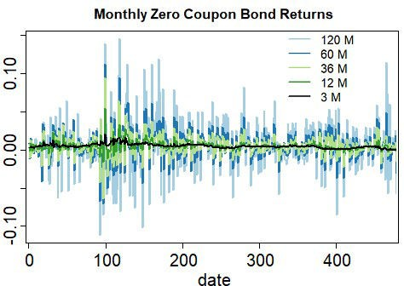

To investigate the performance of bond portfolio strategy, it is useful to calculate the cumulative returns as follows. We can find a stylized fact that long term bond shows the higher returns and higher volatility.

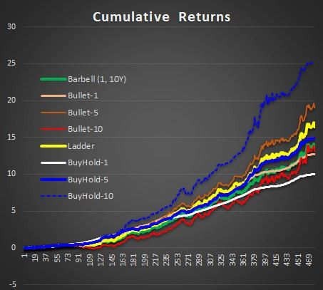

Using mean and standard deviation, we can calculate the Sharpe ratio which is the risk-adjusted return as follows. (In fact, it is typical to use the excess return when calculating the Sharpe ratio and therefore this is the same as we assume 0% risk-free rate)

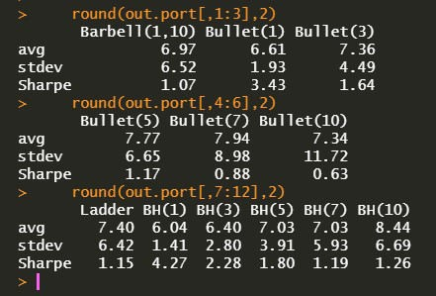

From this post, we have constructed some benchmark bond portfolio and calculate its monthly returns and cumulative performances.

This analysis can be also applied to coupon bond portfolio. For more information, refer to Deguest, Fabozzi, Martellini, and Milhau (2018).

# Reference

Deguest, R., F. Fabozzi, L. Martellini, and V Milhau (2018), “Bond Portfolio Optimization in the Presence of Duration Constraints,” The Journal of Fixed Income 28, 6-26

Diebold, F. X., G. D. Rudebusch, and S. B. Aruoba (2006), “The Macroeconomy and the Yield Curve: A Dynamic Latent Factor Approach,” Journal of Econometrics 131, 309-338.

\(\blacksquare\)